Bela, Lorenzo Miguel D.

DSA /W-F /10-25-23

1. Draw the adjacency list and matrix representation of the weighted graph

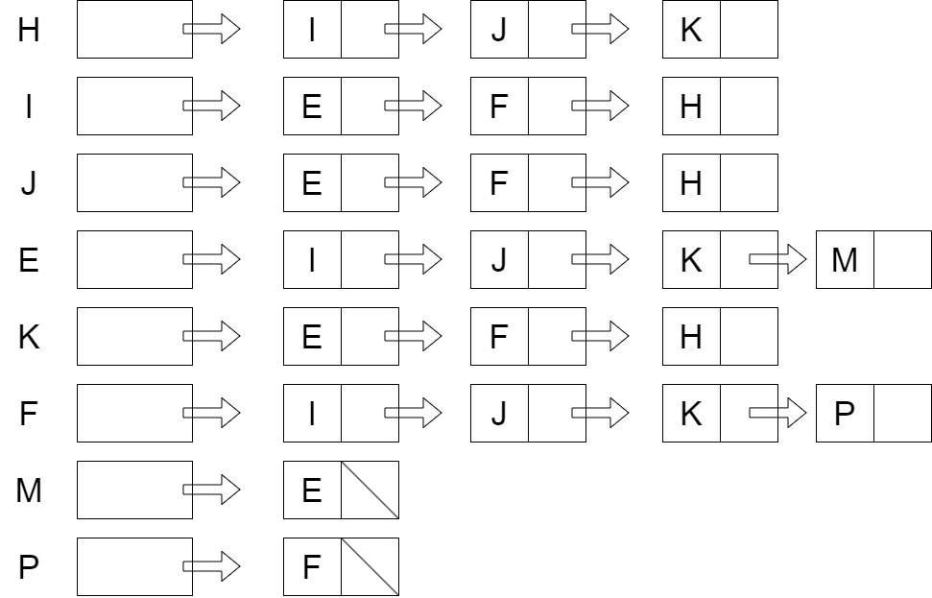

|  |  |  |  |  |  |  |  |  |
| --- | --- | --- | --- | --- | --- | --- | --- | --- |
|  | H | I | J | E | K | F | M | P |
| H | 0 | 1 | 1 | 0 | 1 | 0 | 0 | 0 |
| I | 1 | 0 | 1 | 1 | 0 | 1 | 0 | 0 |
| J | 1 | 1 | 0 | 1 | 0 | 1 | 0 | 0 |
| E | 0 | 1 | 1 | 0 | 1 | 0 | 1 | 0 |
| K | 1 | 0 | 0 | 1 | 0 | 1 | 0 | 0 |
| F | 0 | 1 | 1 | 0 | 1 | 0 | 0 | 1 |
| M | 0 | 0 | 0 | 1 | 0 | 0 | 0 | 0 |
| P | 0 | 0 | 0 | 0 | 0 | 1 | 0 | 0 |

1. Redraw the graph using BFS algorithm

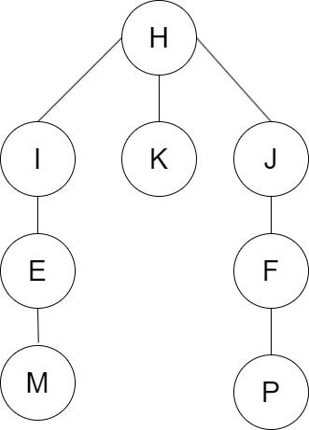

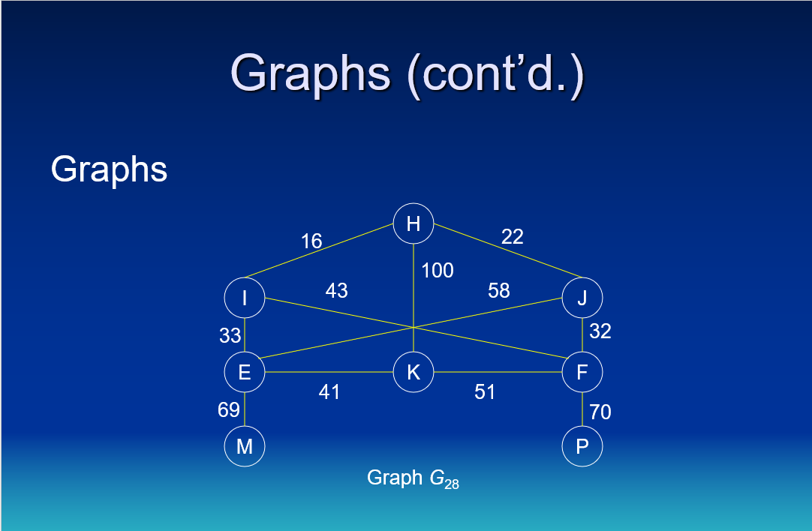

**Graph Elements:**

**Vertices:**

'H', 'I', 'J', 'E', 'K', 'F', 'M', 'N' - Total of **8**  
**Edges:**

('H', 'I'), ('H', 'J'), ('H', 'K'), ('I', 'H'), ('I', 'E'), ('I', 'F'), ('J', 'H'), ('J', 'E'), ('J', 'F'), ('E', 'I'), ('E', 'J'), ('E', 'K'), ('E', 'M'), ('K', 'E'), ('K', 'H'), ('K', 'F'), ('F', 'K'), ('F', 'I'), ('F', 'J'), ('F', 'N'), ('M', 'E'), ('N', 'F') - Total of **22**  
  
**GitHub Link:**  
[**https://github.com/LorenzoBela/58009-DSAA/blob/ee73af733456bc4c6185d484b510a0dcffe0cc30/Long_Quiz_2.ipynb**](https://github.com/LorenzoBela/58009-DSAA/blob/ee73af733456bc4c6185d484b510a0dcffe0cc30/Long_Quiz_2.ipynb)